Lab 6: Initiate Replenishment Flow

In this lab, you will build an Initiate Replenishment skill flow, linking a few skills from previous labs. Check Reorder Quantity and Get Lowest Cost Supplier Skills have been pre-created for you. These skills are nested in the “Check Cost and Reorder” app.

Using this, you will be able to run the procurement order scenario step by step.

1. **Add Skills to Skill Flow**
   1. Click on “Skills and Apps” from the side menu and click on Skill.

* 1. Create a Skill Flow and rename the skill flow (by clicking on the pen icon) to “[Your Name] Initiate Replenishment”, click on save.

* 1. Add the [Your Name] Get Inventory Skills to skill flow. A diagram of a diagram

     Description automatically generated with medium confidence

* + 1. Click on the [Your Name] Get Inventory Skills, and change the default query to “What is the current inventory level for Xtralife?”

* 1. Add Forecast_Quantity_Auto_AI skill to the skillflow

* + 1. Click on Forecast_Quantity_Auto_AI skill and type in the default productName to “Xtralife”

* 1. Look for Check Cost and Reorder App.

* + 1. Add Calculate Reorder Quantity Skill

* + 1. Click on the Calculate Reorder Quantity Skill and click on forecasted_amount box. Select ‘Forecast_Quantity_Auto_AI’ from the dropdown and select ‘ForecastedQuantity’ from the next dropdown.

* + 1. Click on the “current_inventory” box.

* + 1. From the dropdown, select [Your Name] Get Inventory -> Quantity

* + 1. Add Calculate Lowest Cost Supplier (also from Check Cost and Reorder App)

* + 1. Click on the Calculate Lowest Supplier and edit the product_name field.

* + 1. Type in Xtralife into the product_name field.

* 1. As we want to only choose 1 supplier to reorder from, we will need to capture the lowest cost supplier details in a form. Add Input Form (from Custom Forms App)

* + 1. Select “Hide this form from user”. (Optional to give a name)

* + 1. Click on “Add input field”

* + 1. Select “Single Line Text” for the input type, and type in “Supplier Name” in Configuration tab. Click on Apply.

* + 1. Repeat steps 1.1.12 and 1.1.13 for Supplier ID.

* + 1. Lastly, create a field with “Number” as input type and “Cost” as Display label.

Your final form should look something like this.

* + 1. Click on the Supplier Name field and select “Calculate Lowest Supplier”.

* + 1. Select SUPPLIER_NAME.

* + 1. Repeat step 1.1.16 for Supplier ID field. Select Supplier ID from the drop down.

* + 1. Repeat step 1.1.16 for Cost field. Select COST_PER_UNIT from the drop down.

* 1. Add ‘[YourName]_ReorderFlow’ skill from [YourName]_ProcurementAutomations app.

* + 1. Click on the OrderQty field and select Calculate Reorder Quantity from the dropdown. Select reorder_quantity from next dropdown.

* + 1. Click on CostPerUnit box. Select “Input Form” field from the dropdown. Select COST from the next dropdown.

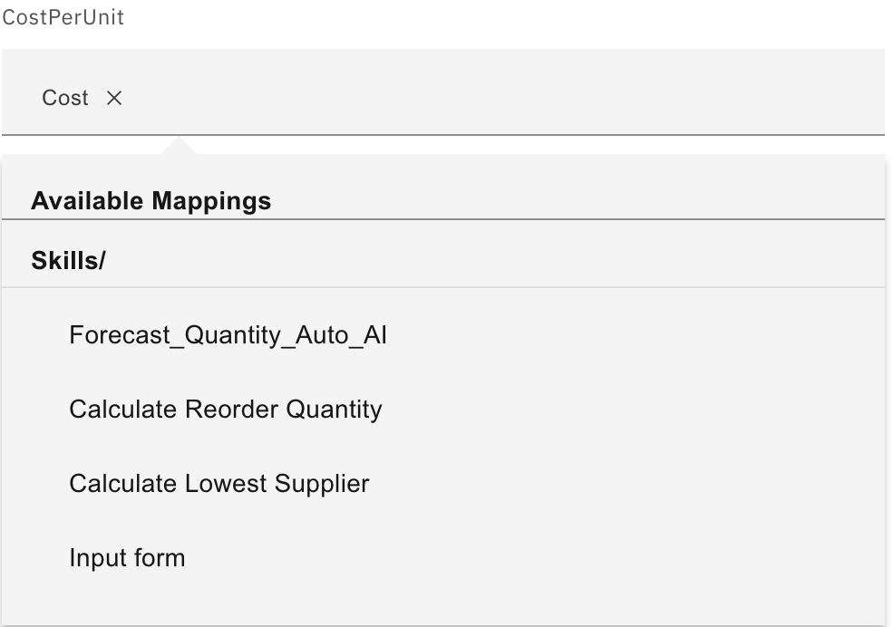

* + 1. Type in ‘Xtralife’ into the ProductName box.

* + 1. Click on SupplierName box and select “Input Form” from the dropdown and then select SUPPLIER NAME from the next drop down

* 1. We will consolidate all the replenishment details in another input form. Add Input Form (from Custom Forms App)

* + 1. Name the form as “Your order details”.

* + 1. Click on “Add input field” and create the following fields:

|  |  |
| --- | --- |
| **Input Type** | **Display Label** |
| Single Line Text | Order Item |
| Number | Order Quantity |
| Single Line Text | Supplier Name |
| Single Line Text | Supplier ID |
| Number | Cost Per Unit |
| Paragraph Text | Email Content |

* + 1. Click on the “Order Item” box and edit the default value to Xtralife.

* + 1. Click on “Order Quantity” box and select “Calculate Reorder Quantity” from the drop down. Select reorder_quantity on the next drop down.

* + 1. Click on “Supplier Name” box and select “Input Form” from the drop down. Select “Supplier Name” on the next drop down. A screenshot of a computer

       Description automatically generated

* + 1. Repeat step 1.1.26 for the “Supplier ID” box, selecting “Supplier ID” from the Available Mappings Menu

* + 1. Click on “Cost Per Unit” box and select “Input Form” from the drop down. Select “Cost” on the next drop down.

* + 1. Click on Email Content box and select “[YourName]_ReorderFlow” from the dropdown. Select EmailOutput from the next dropdown.

* 1. Lastly, click on the arrow on “Actions” and “Save”.

1. **Publish the Skill**
   1. Select Publish
2. **Add Initiate Replenishment Skill Flow**
   1. Go to Chat and Select “Add skills from catalog”.
   2. Look for “[Your Name] Initiate Replenishment” Skill in Skill Flows app.
3. **Use Initiate Replenishment Skill Flow**
   1. Select “[Your Name] Initiate Replenishment” skill flow from the menu.
   2. The first skill in the skill flow will be automatically triggered. Click Apply.

* 1. Once the result is out, select the result and click Apply.

This will automatically trigger the Reorder Quantity skill.

* 1. Once the result is out, Select a Month from the drop down and click Apply.

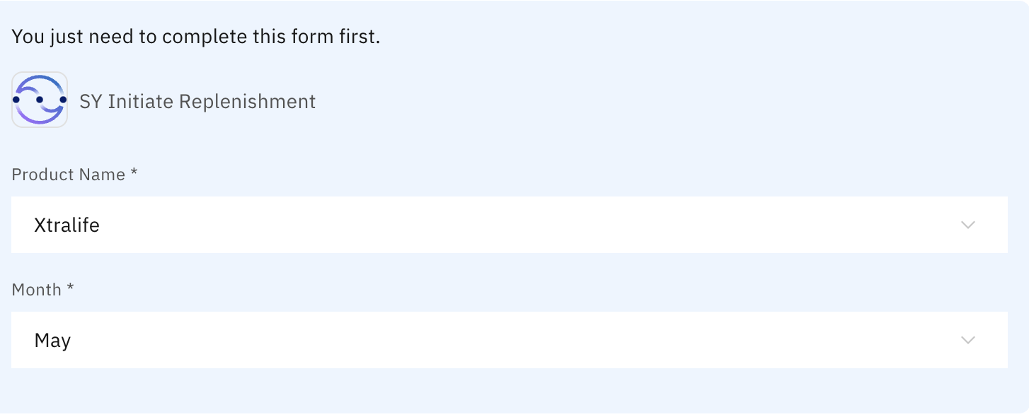

* 1. The output shows the forecasted amount and current inventory as below. click Apply to proceed. This will return the reorder_quantity. A screenshot of a computer

     Description automatically generated

* 1. You will immediately see the “Get Lowest Supplier skill”, with the Product Name filled. Click Apply.

* 1. Once the result is returned, you are free to choose any supplier you want and Click Apply.

* 1. The output will be shown as such.

* 1. Refer to the displayed OrderQty and CostPerUnit and Type in the OrderQty in OrderQtyStr and CostPerunit in CostPerUnitStr input boxes.

* 1. Type any reason in the ‘Reason’ input box such as “festivities around corner” and click on Apply.

* 1. The final output is shown as such:

**Optional Practices:**

The forms currently are editable. To make the output form (or any forms) in a read-only format, please follow the following steps.

1. Go to “Skills and App” page. Look for the “[Your Name] Initiate Replenishment” Skill.

1. Click on the 3 dots and export the skills.

1. This will download a .json file on your local computer.
2. You will need a programme or code editor to edit this .json file.
3. Within the .json file, look for the type: input_form with form_title: “Your order details”.

1. In each schema, you will need to add on “x-ibm-disable”: “true”

1. After adding in into the schemas, save the .json file.
2. You will need to add the skills through the .json file and publish the skills again.

